

Standing Order Form
Please send this form to your bank

To__________________________________________________ __________Bank
Please set up the following Standing Order and debit my/our account
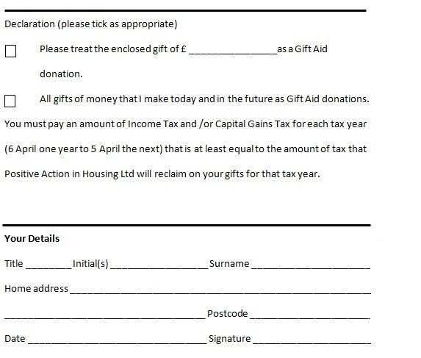
accordingly

- Your Account Details
Name _________________________________ Account Number ______________
Account Holding Branch ___________________Sort Code ____________________

- Payee Details
Pay: POSITIVE ACTION IN HOUSING
Payment reference _______________________________________(e.g. your name)
Account Number: 00447398
Sort Code: 82-20-00

- About the Payment
Frequency _______________________________________________(e.g. monthly)
Date and amount of first payment ____________________________ £ ________
Date and amount of on-going payments _______________________ £ ________

Choose one of the following options:
A, Date of last payment _______________________________________________
B, Until further notice

- Confirmation
Signature ___________________________________ Date ___________________
___________________________________________________________________

